Composite Volume

Definition
# Source: AI Source: Provided by: [Data Path: Persons Table -> ID Column: 1, Name_En Column: Motasem Essam] -> From: [ChatGPT] on [7/25/2026]
Composite Volume is the total volume of a three-dimensional solid formed by combining two or more geometric solids or by removing portions of an existing solid.
It measures the amount of three-dimensional space occupied by the final composite object.
Composite volume calculations involve:
- Adding the volumes of combined components.
- Subtracting the volumes of removed portions.
- Combining addition and subtraction operations.
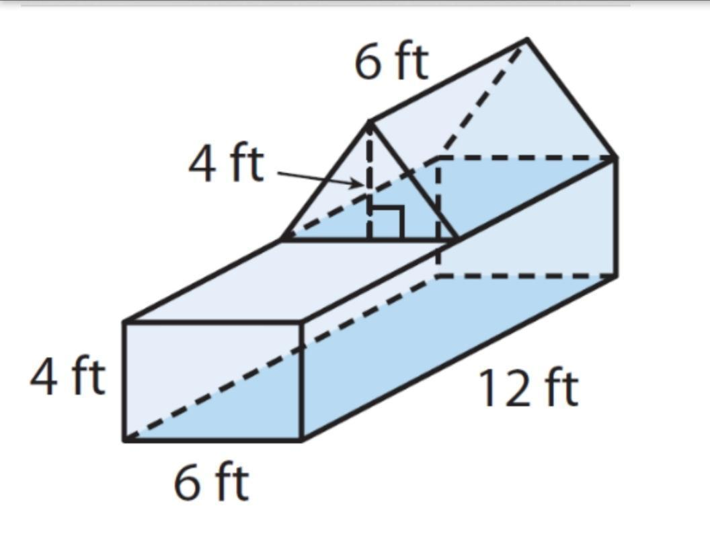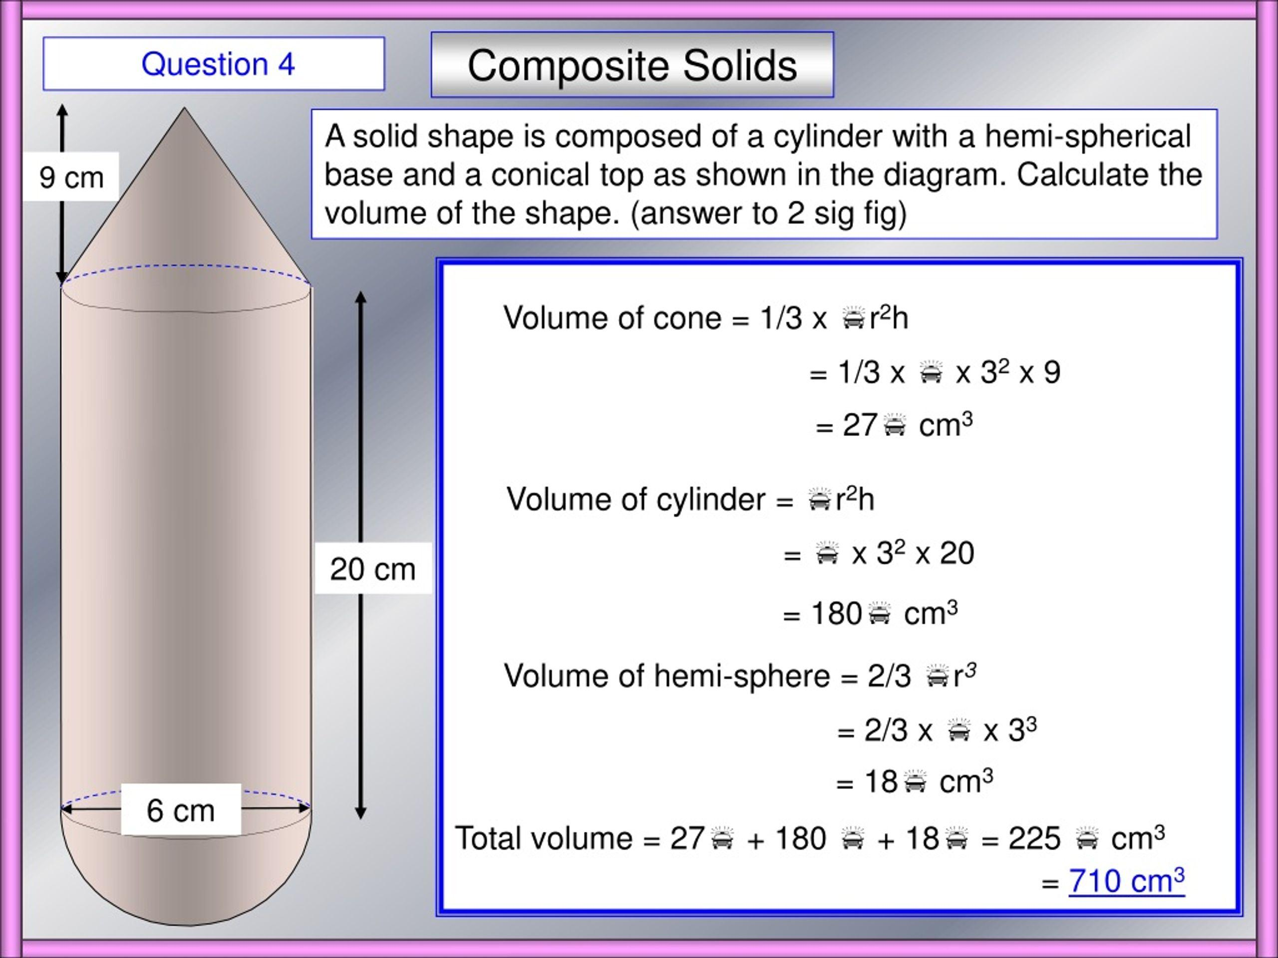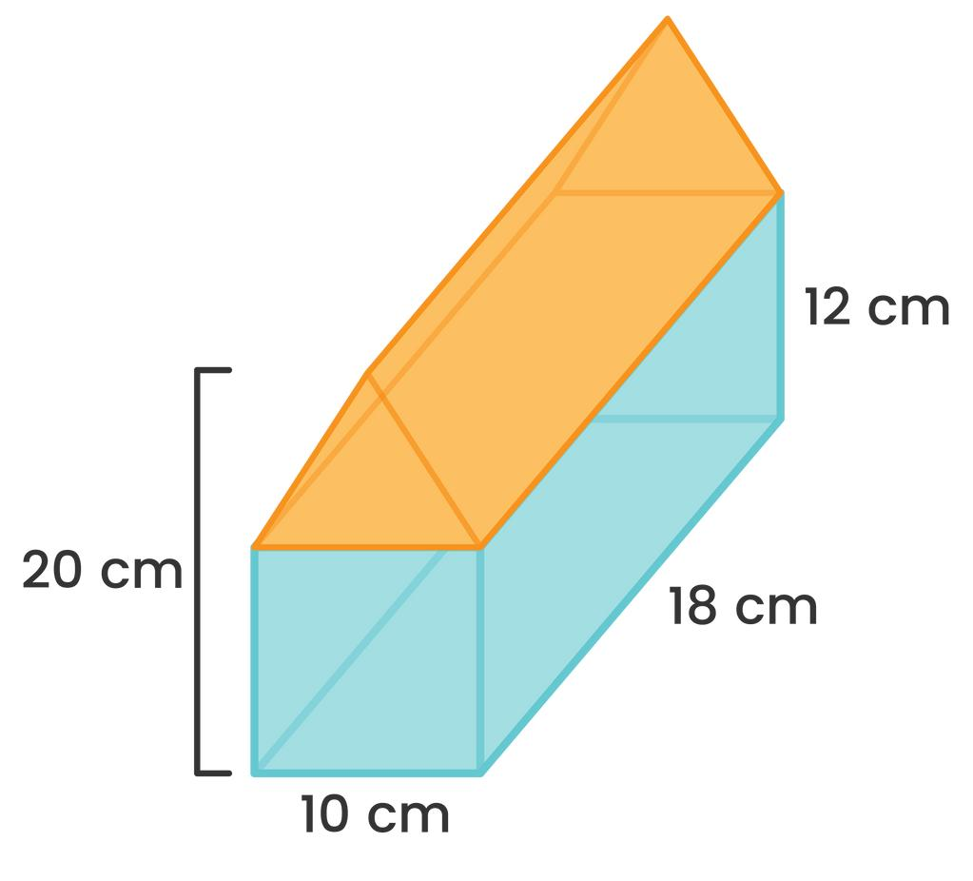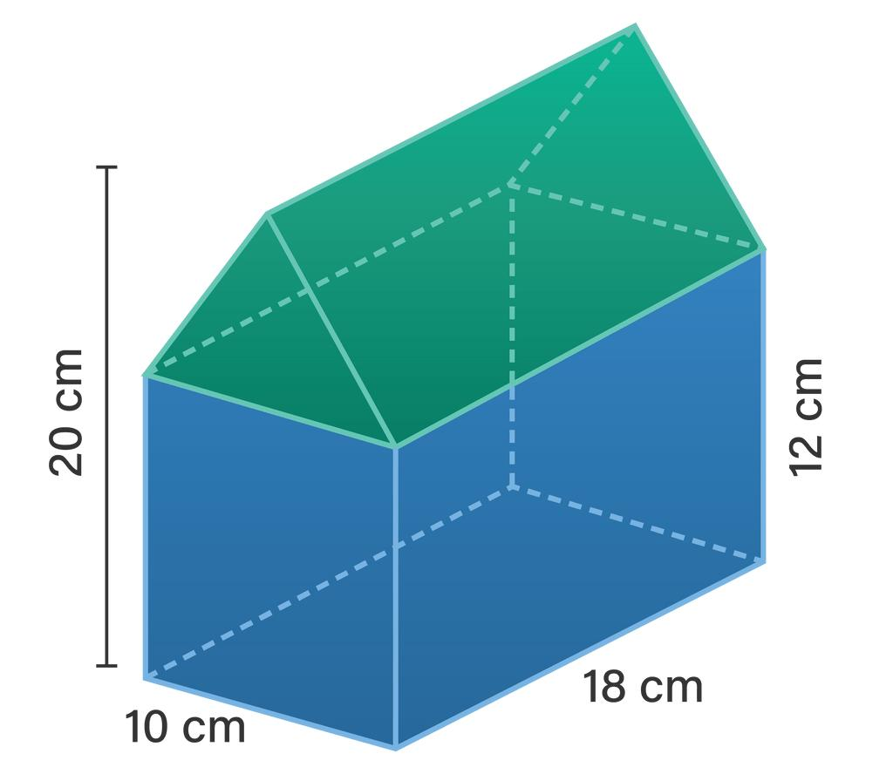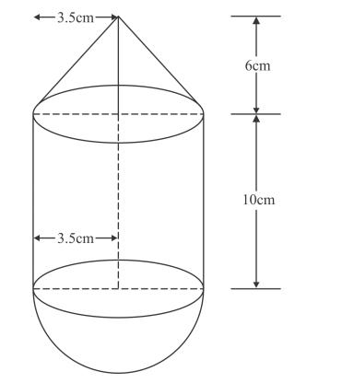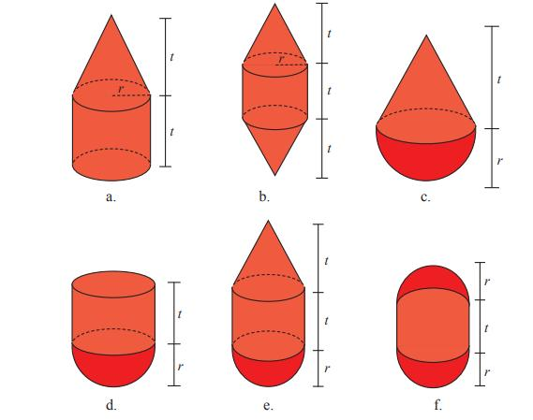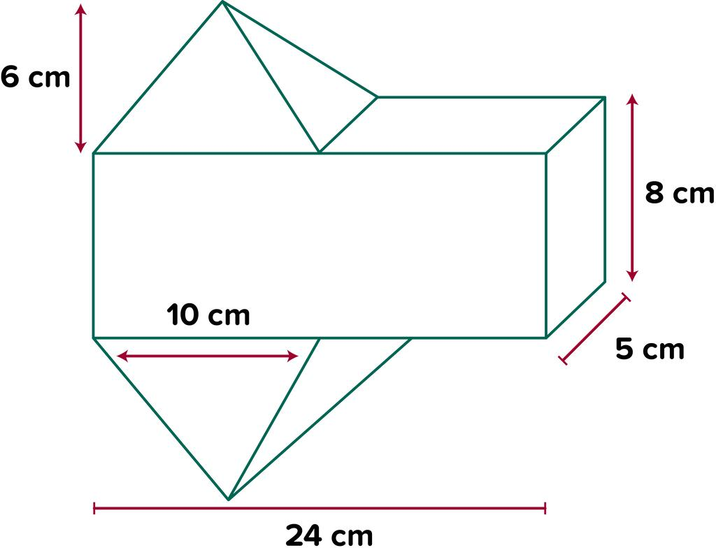

Main Characteristics
# Source: AI Source: Provided by: [Data Path: Persons Table -> ID Column: 1, Name_En Column: Motasem Essam] -> From: [ChatGPT] on [7/25/2026]
- Multiple Components: A composite solid consists of two or more geometric solids or solid sections.
- Additive Calculation: Volumes of separate components are added when they are combined without overlapping.
- Subtractive Calculation: Removed portions, such as holes and cavities, are subtracted.
- Mixed Calculation: Addition and subtraction are used together.
- Overlapping Components: Shared volume regions must be accounted for to avoid double-counting.
- Volume Measurement: Volume is expressed in cubic units, such as ${\text{cm}}^{3}$, ${\text{m}}^{3}$, or ${\text{mm}}^{3}$.

Types of Composite Volume

Additive Composite Volume
# Source: AI Source: Provided by: [Data Path: Persons Table -> ID Column: 1, Name_En Column: Motasem Essam] -> From: [ChatGPT] on [7/25/2026]
Formed by joining two or more solids together without overlapping their interior volumes.
Examples:
- Joined Solids
- Attached Solids
- Stacked Solids
- Arranged Component Solids
- Composite Prisms
- Composite Cylindrical and Conical Solids
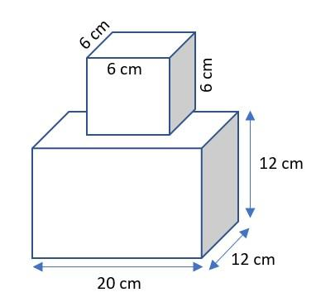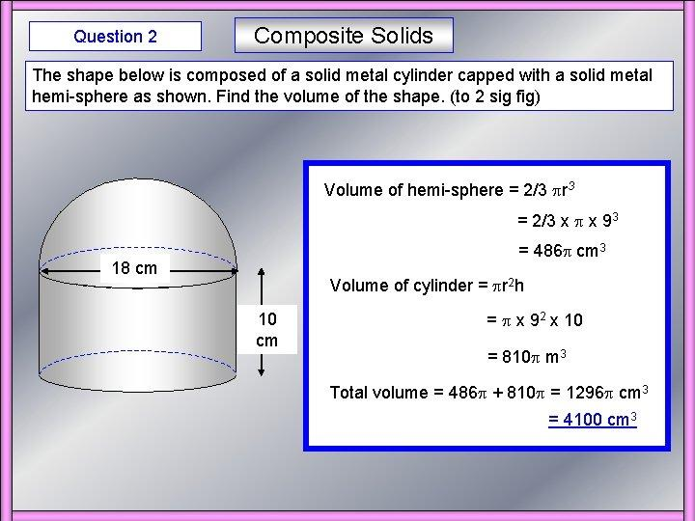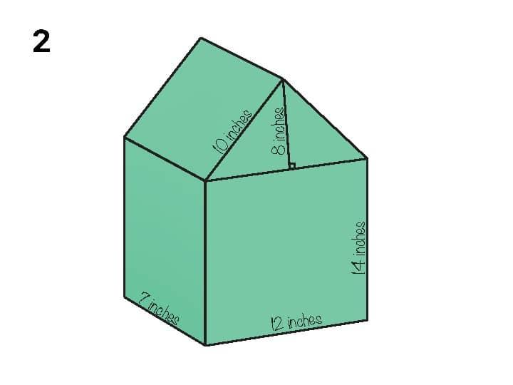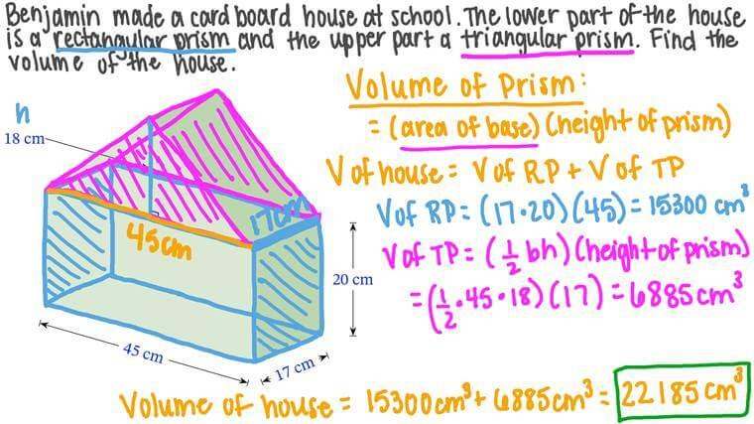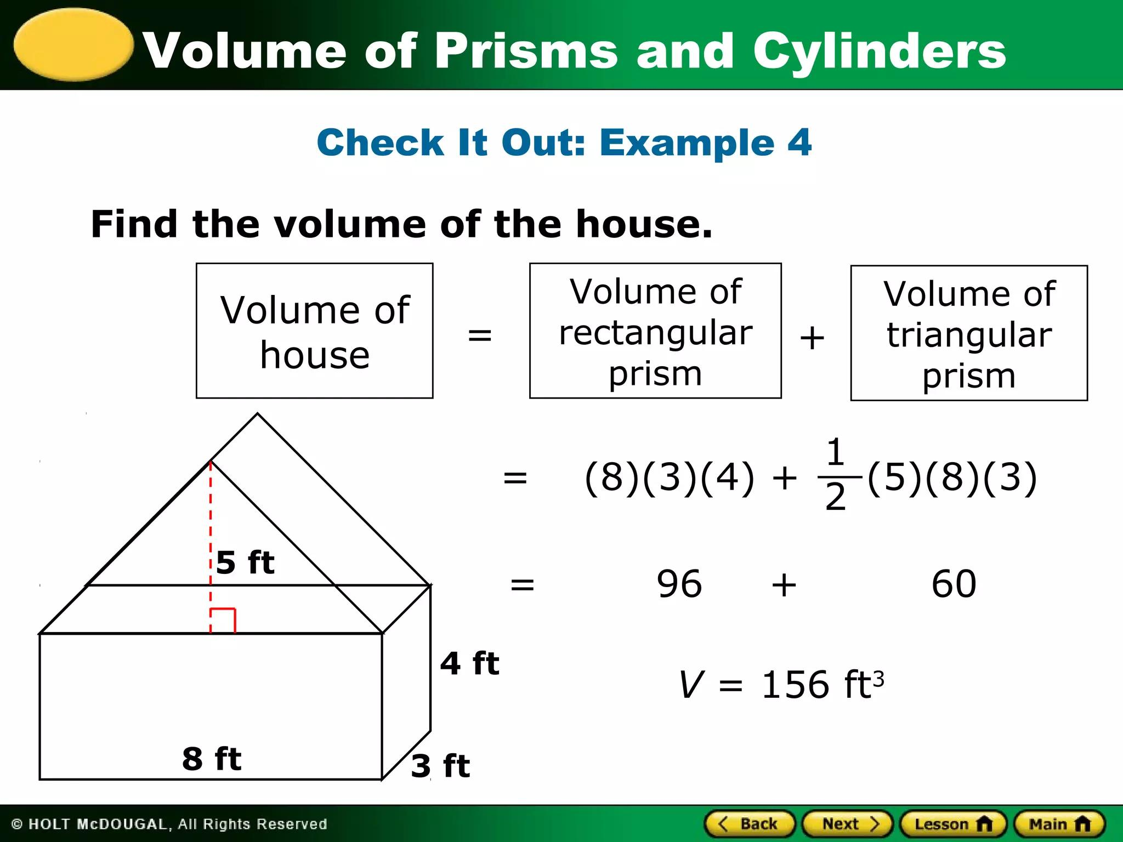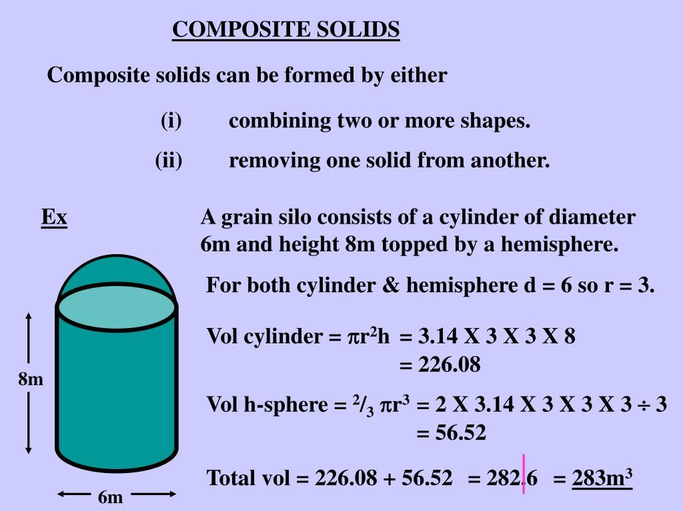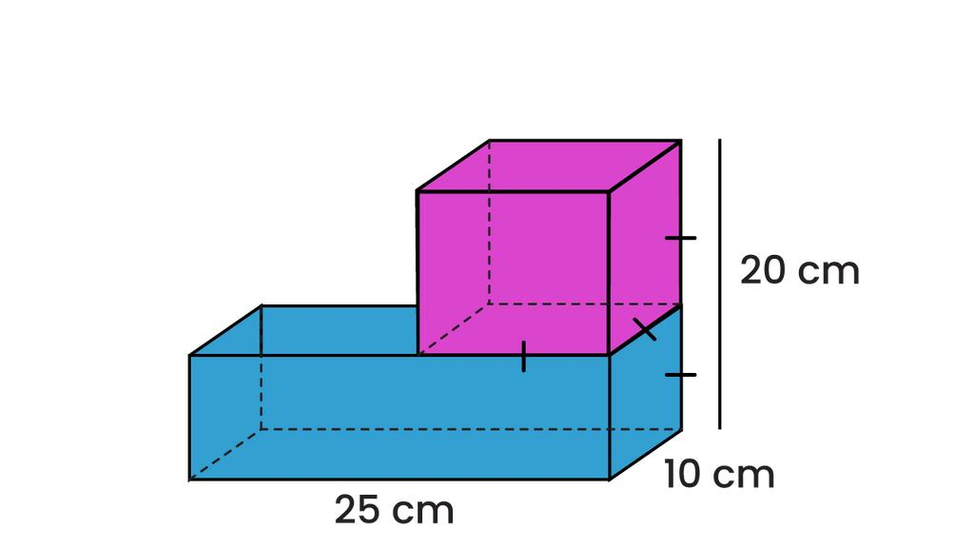
General formula:
$$V_{c}=V_{1}+V_{2}+⋯+V_{n}$$
For components that overlap, their shared volume must be subtracted to avoid double-counting.

Subtractive Composite Volume
# Source: AI Source: Provided by: [Data Path: Persons Table -> ID Column: 1, Name_En Column: Motasem Essam] -> From: [ChatGPT] on [7/25/2026]
Formed by removing one or more portions from an existing solid.
Examples:
- Through-Holes
- Blind Holes
- Cavities
- Recesses
- Cut-Out Sections
- Removed Solid Sections
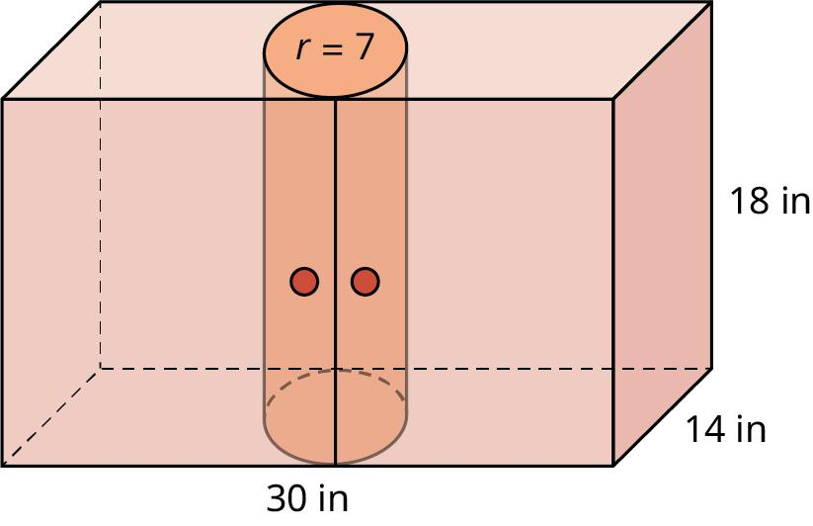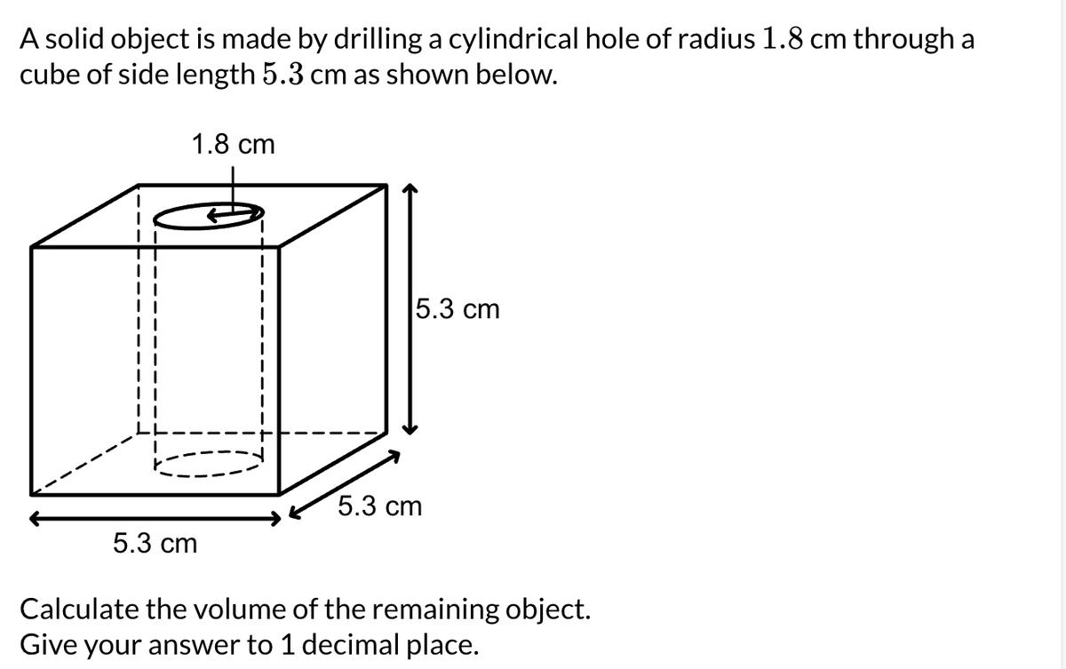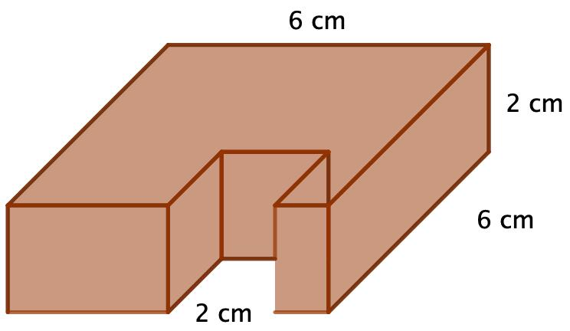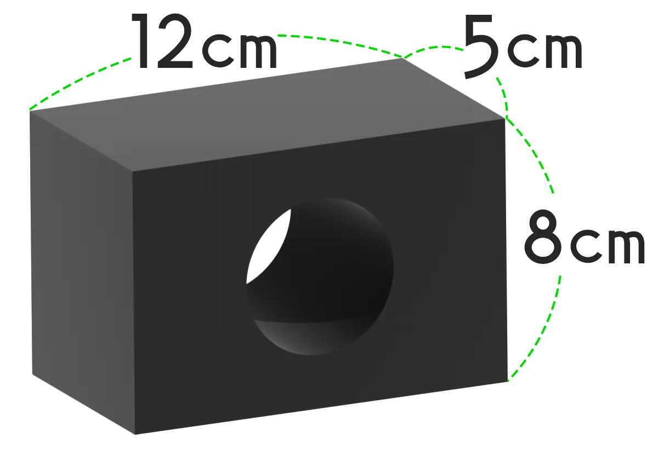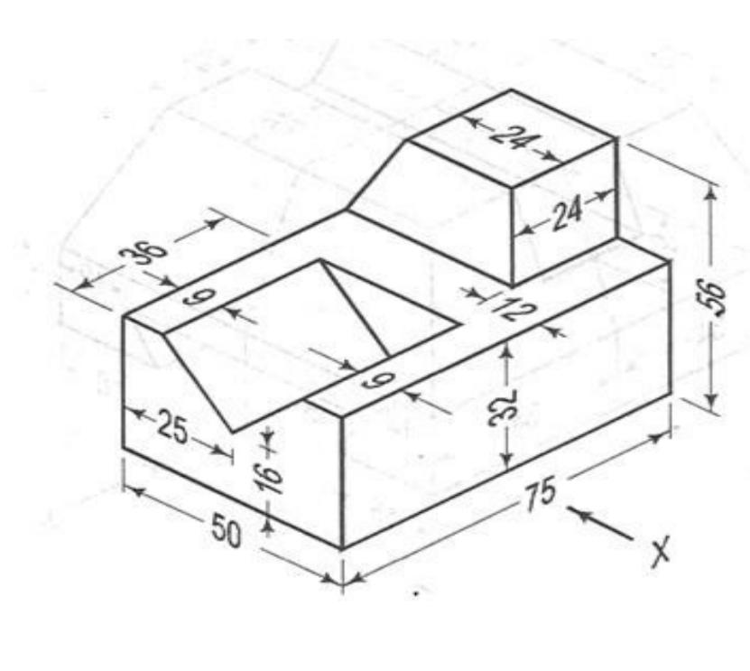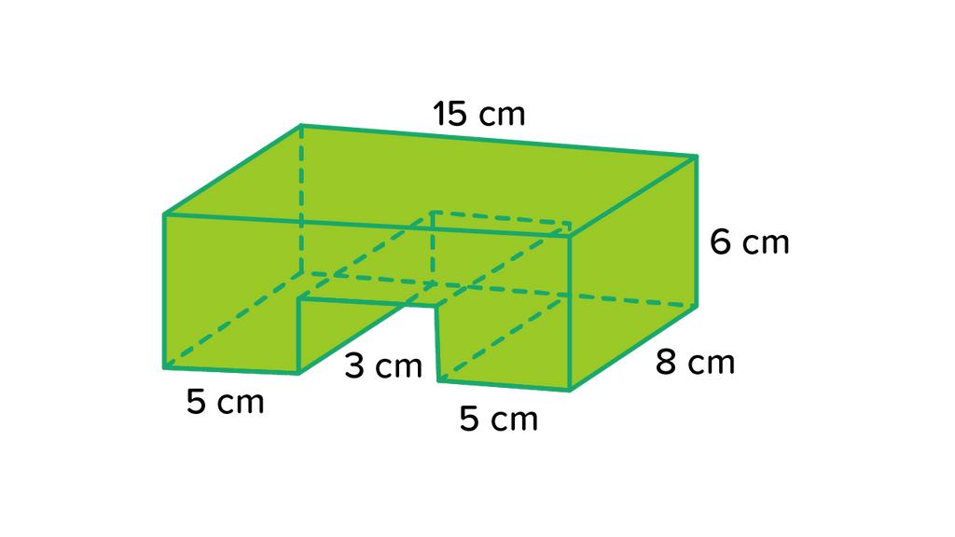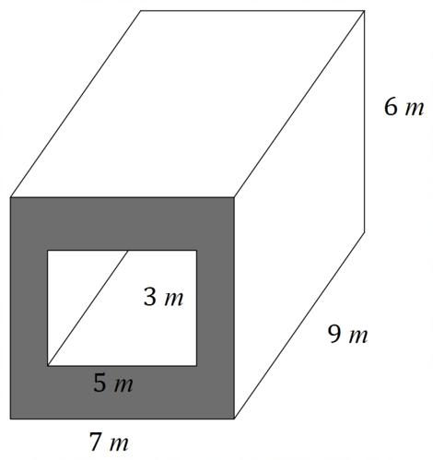
General formula:
$$V_{c}=V_{\text{original}}-V_{\text{removed}}$$
For multiple removed portions:
$$V_{c}=V_{\text{original}}-\sum{V_{\text{removed}}}$$

Mixed Composite Volume
# Source: AI Source: Provided by: [Data Path: Persons Table -> ID Column: 1, Name_En Column: Motasem Essam] -> From: [ChatGPT] on [7/25/2026]
Formed through a combination of adding and removing solid components.
Examples:
- Solids with Attached Components and Holes
- Composite Structures with Cavities
- Joined Solids with Cut-Out Sections
- Multiple Additive and Subtractive Sections
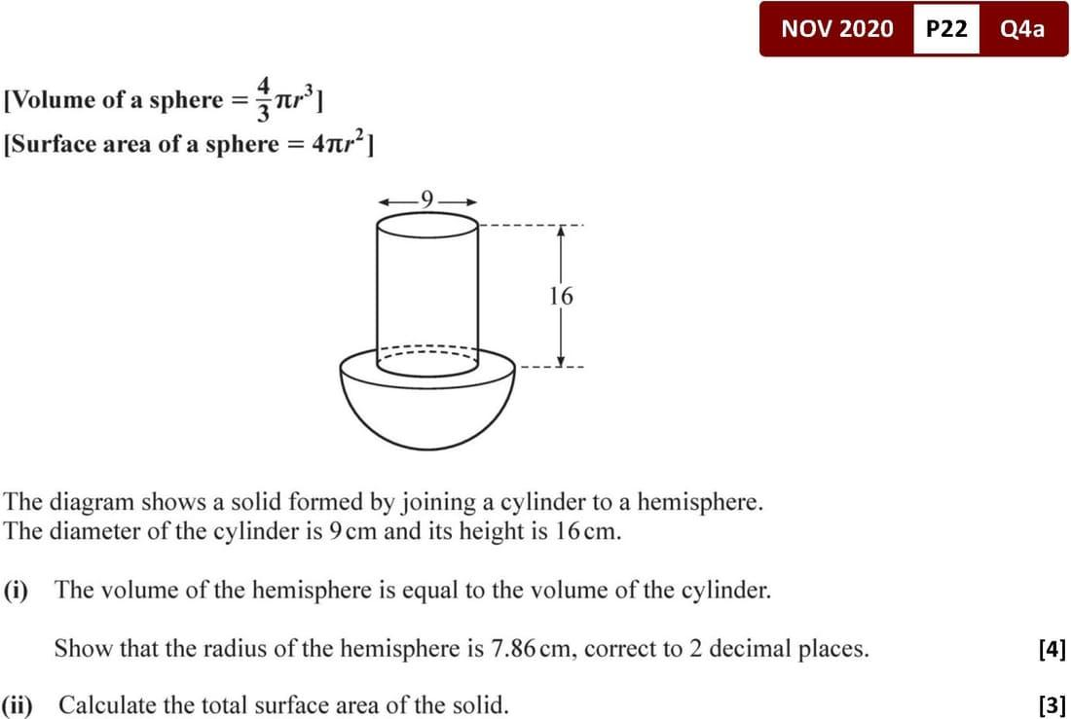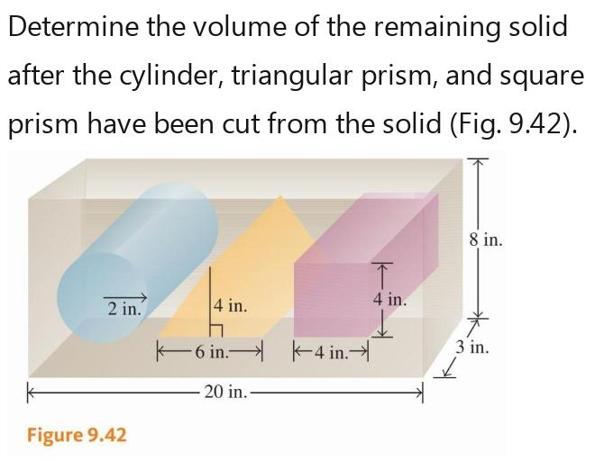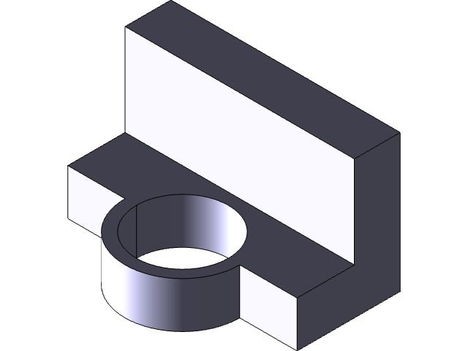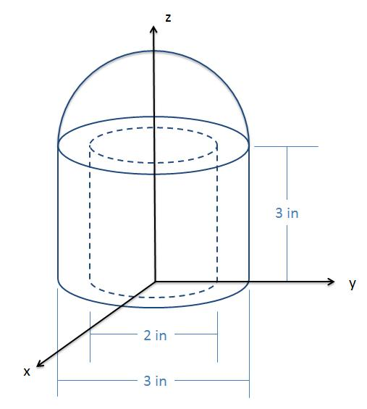
General formula:
$$V_{c}=V_{\text{original}}+V_{\text{added}}-V_{\text{removed}}$$
The formula must also account for overlapping regions where necessary.

Geometric Volume Formulas
# Source: AI Source: Provided by: [Data Path: Persons Table -> ID Column: 1, Name_En Column: Motasem Essam] -> From: [ChatGPT] on [7/25/2026]
The following formulas are commonly used when calculating composite volumes.
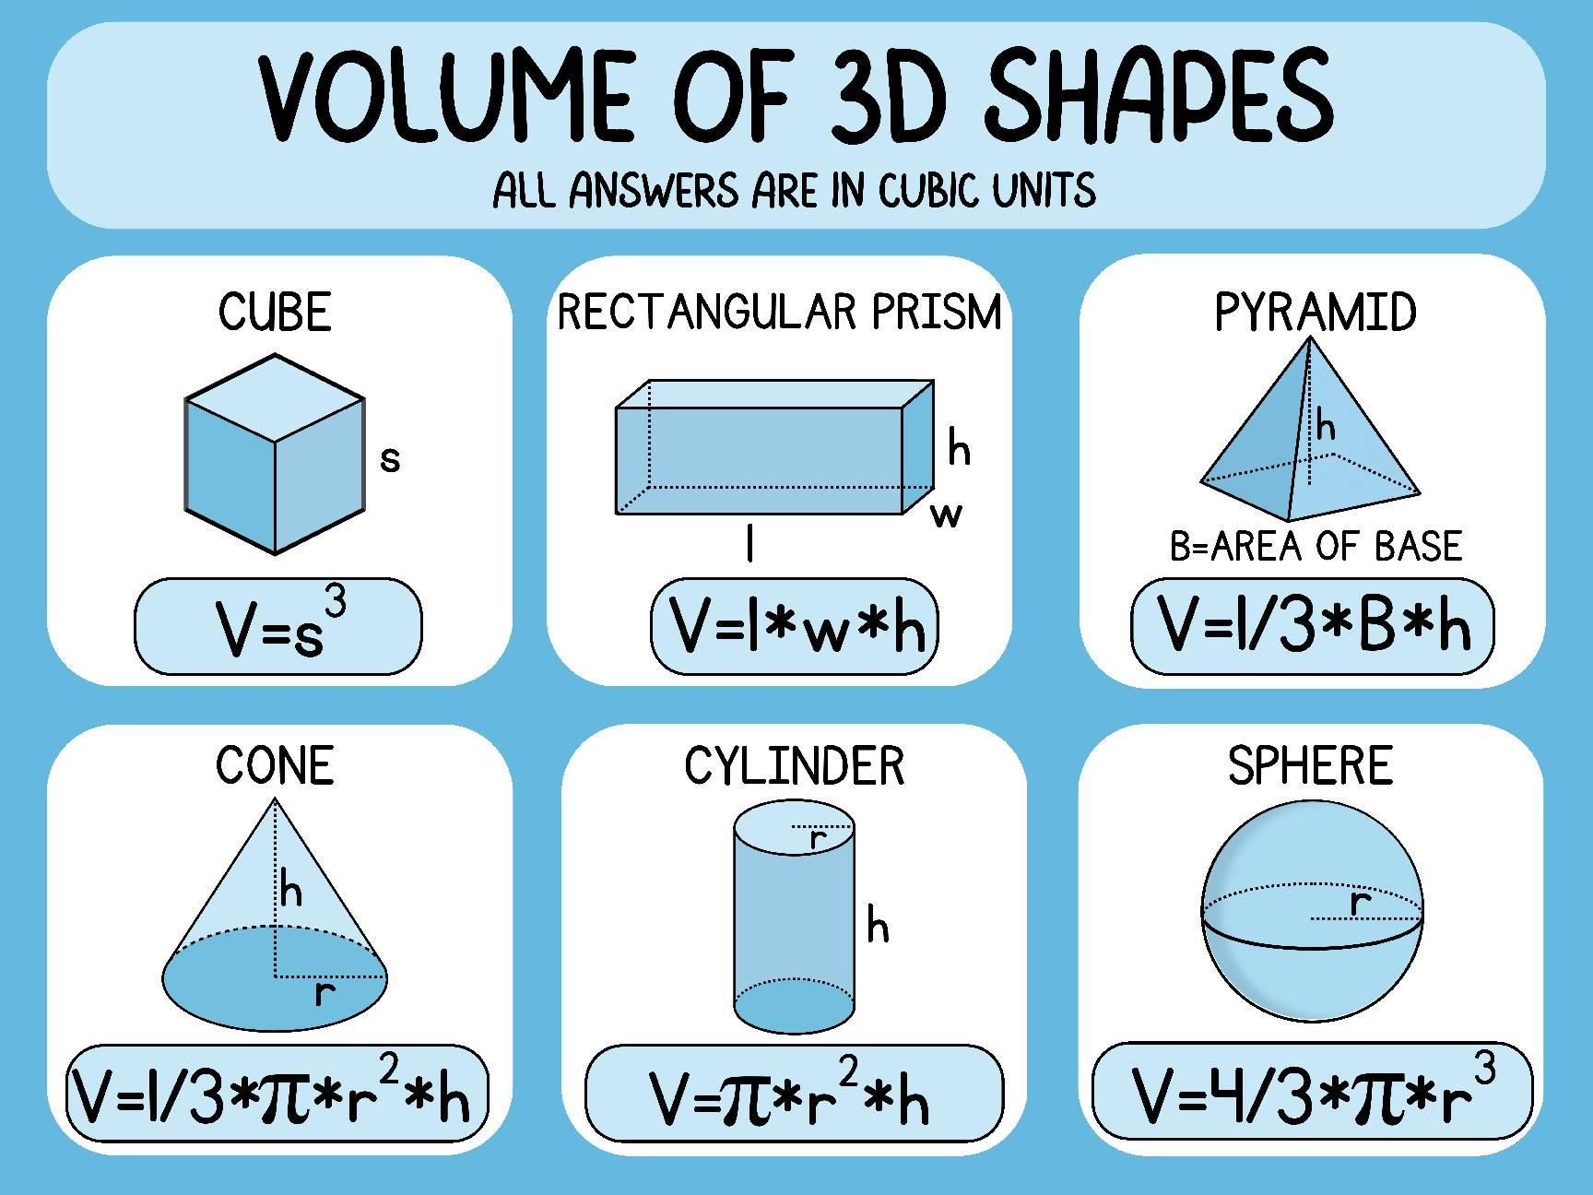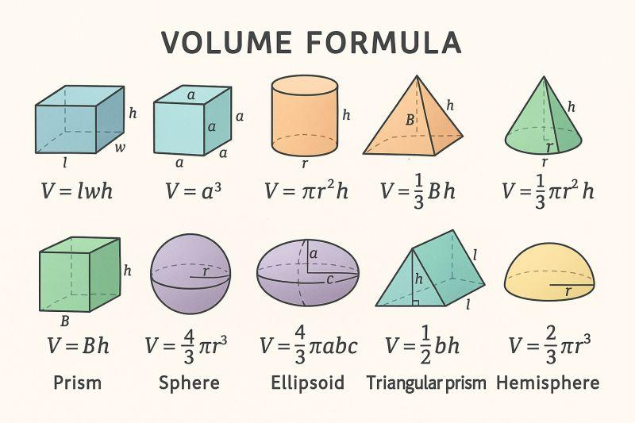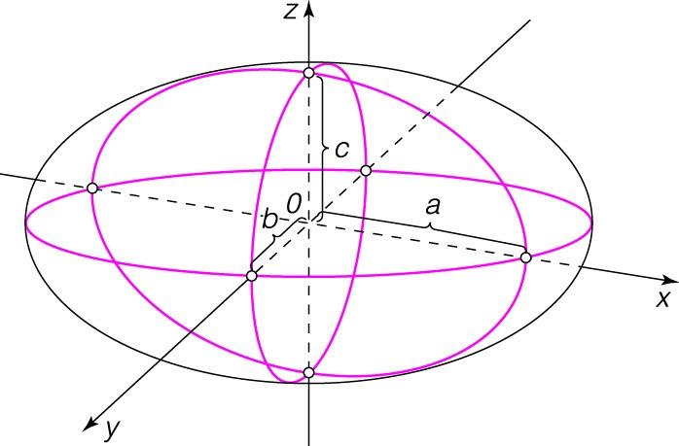
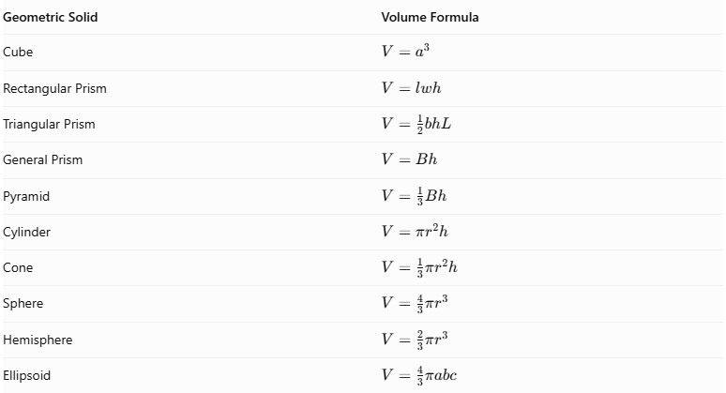
Geometric Solid | Volume Formula
Cube | $$V=a^{3}$$
Rectangular Prism | $$V=lwh$$
Triangular Prism | $$V=\frac{1}{2}bhL$$
General Prism | $$V=Bh$$
Pyramid | $$V=\frac{1}{3}Bh$$
Cylinder | $$V=πr^{2}h$$
Cone | $$V=\frac{1}{3}πr^{2}h$$
Sphere | $$V=\frac{4}{3}πr^{3}$$
Hemisphere | $$V=\frac{2}{3}πr^{3}$$
Ellipsoid | $$V=\frac{4}{3}πabc$$
Where:
- $a$ = cube edge length.
- $l$ = length.
- $w$ = width.
- $h$ = perpendicular height.
- $b$ = triangle base.
- $L$ = prism length.
- $B$ = base area.
- $r$ = radius.
- $a,b,c$ = ellipsoid semi-axis lengths.

Composite Volume Calculation Procedures

Additive Composite Volume Calculation
# Source: AI Source: Provided by: [Data Path: Persons Table -> ID Column: 1, Name_En Column: Motasem Essam] -> From: [ChatGPT] on [7/25/2026]
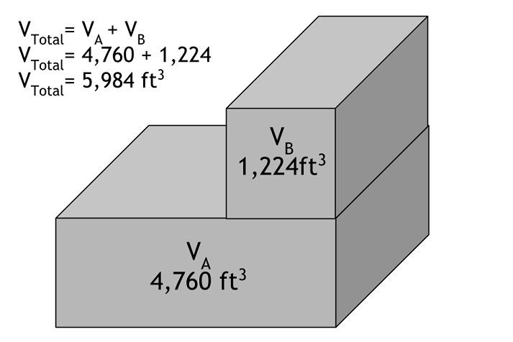
- Identify all component solids.
- Divide the composite object into recognizable geometric solids.
- Determine the dimensions of each component.
- Calculate each component's volume using its appropriate formula.
- Add the component volumes.
- If components overlap, subtract the volume of their shared regions.
- Express the final result in cubic units.
Example: Two Joined Rectangular Prisms
A rectangular prism has dimensions $4×3×2$, and another has dimensions $5×3×2$. They are joined without overlapping their volumes.
$$V_{1}=4×3×2=24$$
$$V_{2}=5×3×2=30$$
$$V_{c}=24+30$$
$$\boxed{V_{c}=54{\text{ units}}^{3}}$$

Subtractive Composite Volume Calculation
# Source: AI Source: Provided by: [Data Path: Persons Table -> ID Column: 1, Name_En Column: Motasem Essam] -> From: [ChatGPT] on [7/25/2026]
- Identify the original solid.
- Identify the removed section or sections.
- Determine the dimensions of the removed portions.
- Calculate the original volume.
- Calculate the total removed volume.
- Subtract the removed volume from the original volume.
- Express the final result in cubic units.
Example: Cylinder with a Through-Hole
A cylindrical solid has an outer radius $R$, an inner cylindrical hole of radius $r$, and height $h$.
$$V_{\text{original}}=πR^{2}h$$
$$V_{\text{hole}}=πr^{2}h$$
$$V_{c}=πR^{2}h-πr^{2}h$$
$$\boxed{V_{c}=πh(R^{2}-r^{2})}$$

Mixed Composite Volume Calculation
# Source: AI Source: Provided by: [Data Path: Persons Table -> ID Column: 1, Name_En Column: Motasem Essam] -> From: [ChatGPT] on [7/25/2026]
- Identify the original solid and all added components.
- Identify all removed portions.
- Divide the object into recognizable geometric solids.
- Calculate the volumes of the original and added components.
- Calculate the volumes of the removed portions.
- Account for overlapping regions where necessary.
- Subtract the removed volumes and add the remaining component volumes.
- Express the final result in cubic units.
Example: Cylinder with an Attached Hemisphere and a Cylindrical Hole
A hemisphere of radius $r$ is attached to the top of a cylinder with the same radius and height $h$. A cylindrical hole of radius $s$ passes vertically through the cylindrical portion only.
$$V_{\text{cylinder}}=πr^{2}h$$
$$V_{\text{hemisphere}}=\frac{2}{3}πr^{3}$$
$$V_{\text{hole}}=πs^{2}h$$
Therefore:
$$V_{c}=πr^{2}h+\frac{2}{3}πr^{3}-πs^{2}h$$
$$\boxed{V_{c}=πh(r^{2}-s^{2})+\frac{2}{3}πr^{3}}$$

Main Classification
# Source: AI Source: Provided by: [Data Path: Persons Table -> ID Column: 1, Name_En Column: Motasem Essam] -> From: [ChatGPT] on [7/25/2026]
Composite Volume Classification Tree
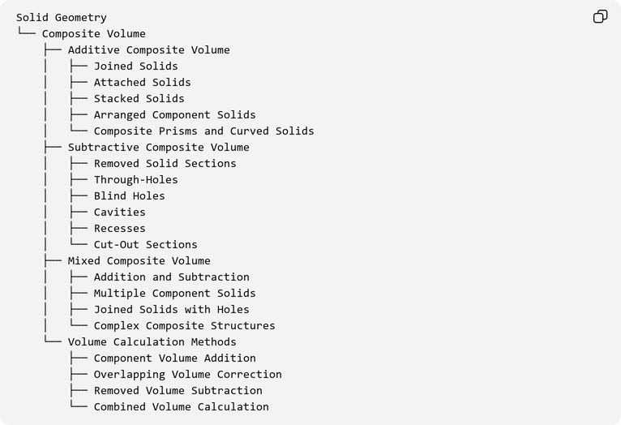
Solid Geometry
└── Composite Volume
├── Additive Composite Volume
│ ├── Joined Solids
│ ├── Attached Solids
│ ├── Stacked Solids
│ ├── Arranged Component Solids
│ └── Composite Prisms and Curved Solids
├── Subtractive Composite Volume
│ ├── Removed Solid Sections
│ ├── Through-Holes
│ ├── Blind Holes
│ ├── Cavities
│ ├── Recesses
│ └── Cut-Out Sections
├── Mixed Composite Volume
│ ├── Addition and Subtraction
│ ├── Multiple Component Solids
│ ├── Joined Solids with Holes
│ └── Complex Composite Structures
└── Volume Calculation Methods
├── Component Volume Addition
├── Overlapping Volume Correction
├── Removed Volume Subtraction
└── Combined Volume Calculation

Applications
# Source: AI Source: Provided by: [Data Path: Persons Table -> ID Column: 1, Name_En Column: Motasem Essam] -> From: [ChatGPT] on [7/25/2026]
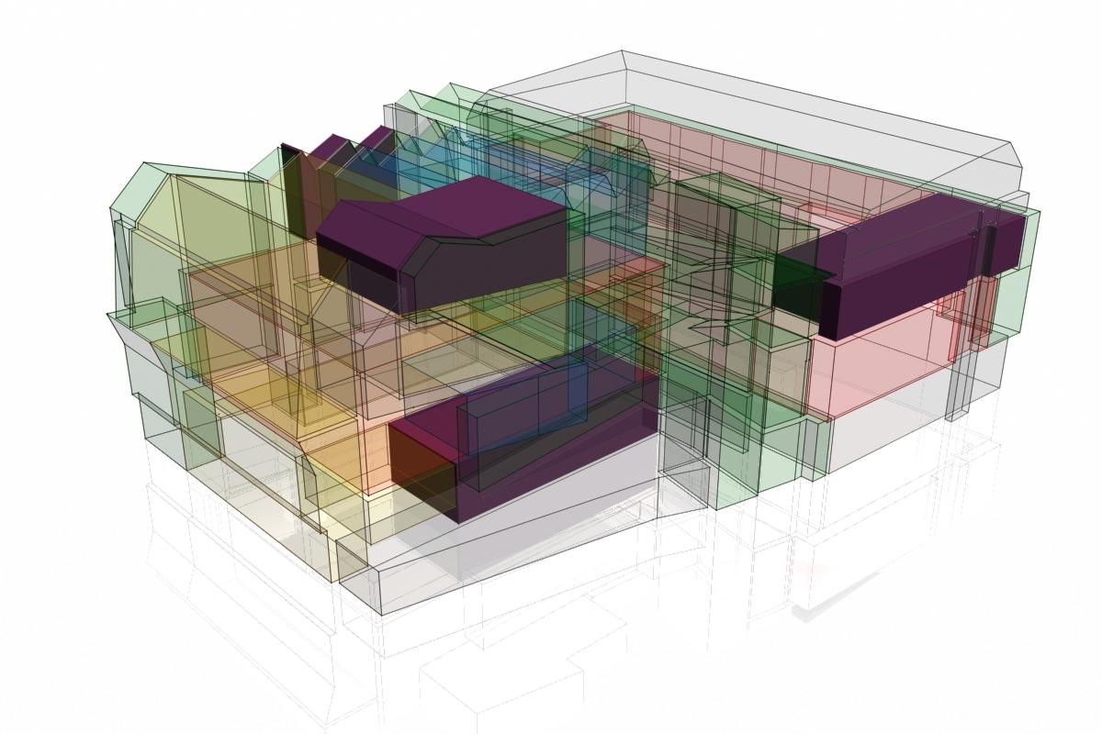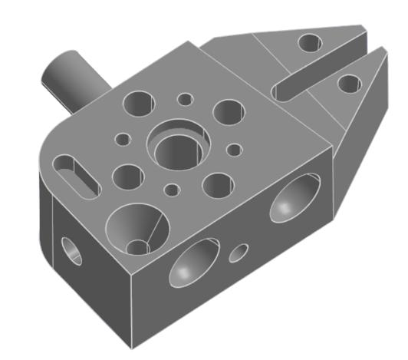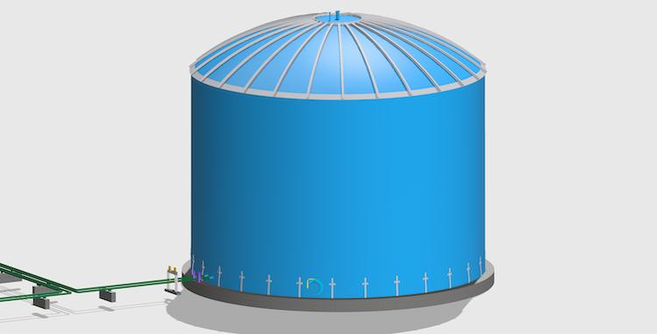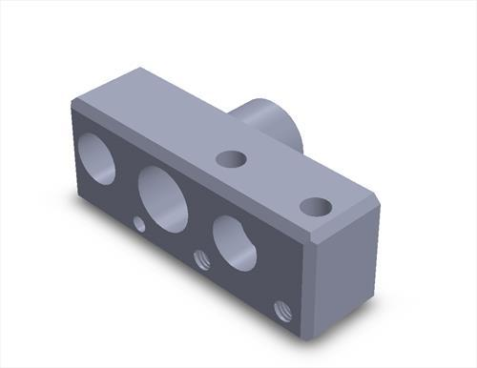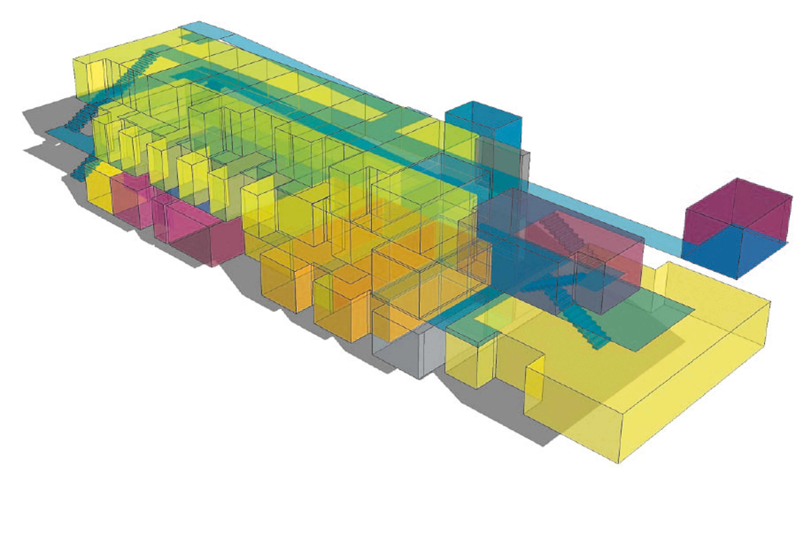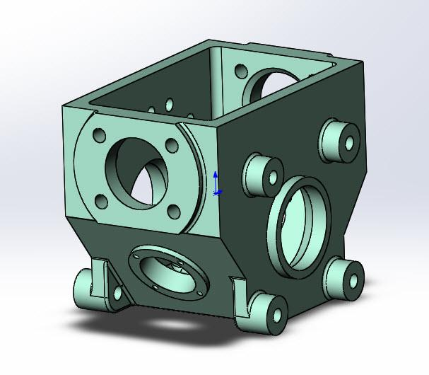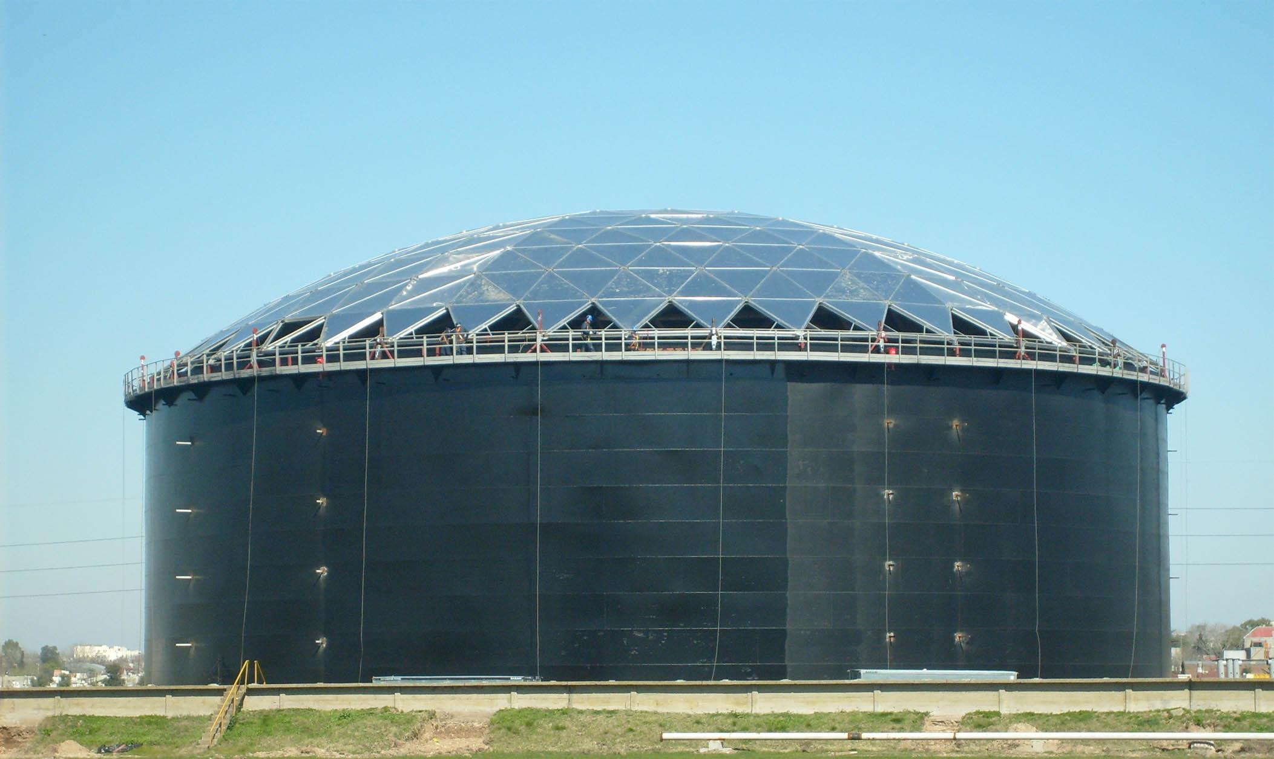
- Architecture: Calculating the volume of buildings composed of different geometric sections.
- Engineering: Determining the volume of complex mechanical components.
- Manufacturing: Estimating the amount of material required to produce objects.
- Construction: Calculating concrete, soil, and other material quantities.
- Packaging: Determining the internal capacity of containers and packages.
- Industrial Design: Calculating the volume of products with attached components, holes, and cavities.

Key Points
# Source: AI Source: Provided by: [Data Path: Persons Table -> ID Column: 1, Name_En Column: Motasem Essam] -> From: [ChatGPT] on [7/25/2026]
- Composite volume measures the space occupied by a combined three-dimensional object.
- Additive composite volume involves combining component volumes.
- Subtractive composite volume involves removing portions from an existing solid.
- Mixed composite volume combines addition and subtraction.
- Overlapping regions must not be counted more than once.
- Internal boundaries between joined solids do not affect the total volume.
- The final answer must be expressed in cubic units.

Important Distinction
# Source: AI Source: Provided by: [Data Path: Persons Table -> ID Column: 1, Name_En Column: Motasem Essam] -> From: [ChatGPT] on [7/25/2026]
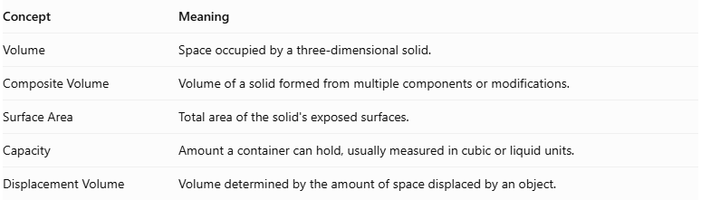
Concept | Meaning
Volume | Space occupied by a three-dimensional solid.
Composite Volume | Volume of a solid formed from multiple components or modifications.
Surface Area | Total area of the solid's exposed surfaces.
Capacity | Amount a container can hold, usually measured in cubic or liquid units.
Displacement Volume | Volume determined by the amount of space displaced by an object.

Conclusion
# Source: AI Source: Provided by: [Data Path: Persons Table -> ID Column: 1, Name_En Column: Motasem Essam] -> From: [ChatGPT] on [7/25/2026]
Composite Volume is used to calculate the total space occupied by complex three-dimensional objects formed through the combination or removal of geometric solids. It involves adding component volumes, subtracting removed portions, and correcting for overlapping regions. Understanding composite volume is essential in geometry, architecture, engineering, manufacturing, construction, and industrial design.

